Science Worksheet
Student’s Name
Institution Affiliation

CHEMISTRY

  - An element is a pure chemical substance made up of multiple atoms that are of the same type. Examples include sodium and chlorine. A compound is a substance made up of various different elements chemically combined in given proportions. An example is Sodium Chloride.
  - An atom is a small particle of an element which does not exist independently. An example is the hydrogen atom (H). A Molecule is the smallest unit of a compound consisting of a set of atoms held together by a chemical bond. An example is the hydrogen molecule (H₂).
  - A mixture refers to a group of substances physically combined and can be separated through a physical process, for example, a mixture of water and sand. A pure substance can either be an element or a compound that cannot be separated into any other form of matter, for instance, water.
- Physical properties of a substance are the characteristics that define the substance without a chemical reaction, for instance the mass, density, melting and boiling points. Chemical properties of a substance refer to the characteristics that define that substance after a chemical reaction has occurred. For example, oxidation state.
- Vinegar – H₄C₂O₂
Type of elements present | Number of atoms of each element
Hydrogen | 4
Carbon | 2
Oxygen | 2
- Physical properties of vinegar:
    - Colorless liquid.
    - Sour taste.
    - Pungent smell.
    - Density of 1.05 g/ml.
    - Melting point of 16 ⁰C and boiling point of 118 ⁰C.
    - Highly soluble in ethanol, methanol and water.
Chemical Properties.
- Weak organic acid
- pH of 5 to 6.
- Solubility in water happens because hydrogen bonds are formed between oxygen atoms and hydrogen atoms that make water.
The properties of carbon/oxygen and those of vinegar are different because vinegar is a compound made up of carbon, oxygen and hydrogen in their specific ratios while carbon and oxygen are molecules each on their own.
- Metals – high density, extremely high melting points, good conductors of heat and electricity, good ductility.
Non-metals – low density, low melting points, poor conductors of heat and electricity, poor ductility.
Metalloids – shiny, semi-conductors of heat and electricity, medium melting points.
- Hydrogen – element.
Sugar (C6H1206 ) – compound.
Zinc Chloride – compound.
Water – compound.
Iron – element.

Chemical Formula | Elements Present | Number of Each Type of Element
CH₄ | Carbon, Hydrogen | Carbon – 1  Hydrogen - 4
NaHCO₃ | Sodium, Hydrogen, Carbon, Oxygen | Sodium – 1  Hydrogen - 1  Carbon – 1  Oxygen - 3
Mg(OH)₂ | Magnesium, Oxygen, Hydrogen. | Magnesium – 1  Oxygen – 2  Hydrogen - 2
- Elements and symbols
  - Hydrogen – H
  - Helium – He
  - Lithium – Li
  - Beryllium – Be
  - Boron – B
  - Carbon – C
  - Nitrogen – N
  - Oxygen – O
  - Fluorine – F
  - Neon – Ne
  - Sodium – Na
  - Magnesium – Mg
  - Aluminum – Al
  - Silicon – Si
  - Phosphorous – P
  - Sulfur – S
  - Chlorine – Cl
  - Argon – Ar
  - Potassium – K
  - Calcium – Ca
  - Iron – Fe
  - Zinc – Zn
  - Lead – Pb
  - Gold – Au.
  - Silver - Ag
  - Nickel – Ni
  - Co – Cobalt
  - Br – Bromine
  - Iodine – I
  - Mercury – Hg
  - Krypton – Kr
  - Copper – Cu.

  - Noble gases – group 8
  - Alkali metals – group 1
  - Halogens – group 7
  - Example of an alkaline earth metal – Calcium.
  - Noble gases are non-reactive because their electron shells have complete number of electrons therefore they are stable.
  - Alkali metals are highly reactive – they need to lose one electron to attain a stable nature.
  - Halogens are highly reactive because the need to gain one electron in their outermost electron shell to attain a stable nature.

  - Noble gases – He, Ne, Ar, K
  - Halogens - F, Cl, Br, I
  - Alkaline Earth Metals - Be, Mg, Ca, Sr
  - Alkali metals - Li, Na, K, Rb

  - valence electrons increases by one as you move across a period
  - electron shells increases by one as you move down a group
  - number of valence electrons in an atom is the same as its group
  - number of electron shells in an atom is the same as the period
  - Reactivity increases as you move up a group.

  - K

19P
20N
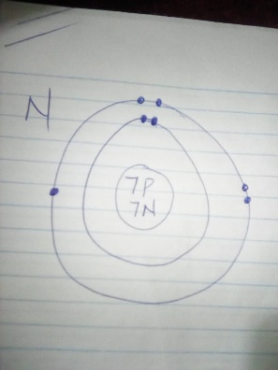
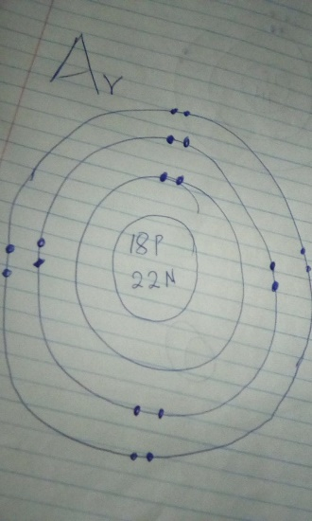

Symbol | Element name | Atomic number | Atomic mass | # of protons | # of neutrons | # of electrons | Solid, liquid or gas | Metal, Nonmetal Metalloid
K | Potassium | 19 | 39 | 19 | 20 | 19 | solid | metal
F | Fluorine | 9 | 19 | 9 | 10 | 9 | gas | nonmetal
S | Sulfur | 16 | 32 | 16 | 16 | 16 | solid | nonmetal
Br | Bromine | 35 | 80 | 35 | 45 | 35 | gas | nonmetal
C | Carbon | 6 | 12 | 6 | 6 | 6 | gas | nonmetal
- Elements lose or gain electrons to attain their stable nature since they cannot exist without stabilizing. To determine how many electrons an element needs to gain or lose, consider the outermost electron shell, which should contain eight electrons. Therefore the electrons that should be gained or lost should leave the outermost shell with eight.
- Isotopes are elements that contains similar atomic numbers but with different atomic masses. For example carbon 14 and carbon 12.

Element | Number of Valence Electrons | Easier to gain or lose electrons? | Ionic Charge | Bohr-Rutherford Diagram of Ion
Lithium | 1 | lose | + | 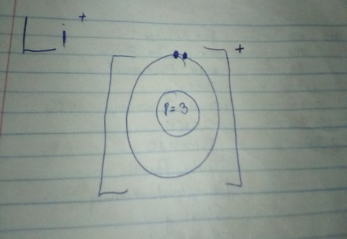
Nitrogen | 3 | gain | - | 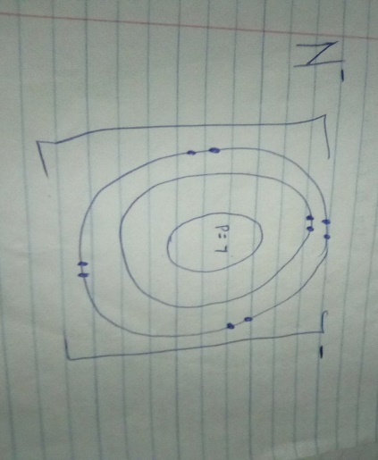
Chlorine | 1 | gain | - | 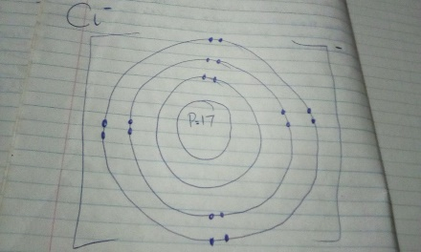
- Carbon 14 - ¹⁴C, Bromine - ⁸¹Br, Nitrogen 17 - ¹⁷N, Platinum 169 – ¹⁶⁹Pt.

ELECTRICITY
Static Electricity

  - Objects with more electrons than protons have a negative charge.
  - Objects with more protons than electrons have a positive charge.
  - Objects with equal numbers of protons and electrons have a neutral charge.
- Laws of electric charges
    - Unlike charges attract.
    - Like charges repel.
    - Charged objects attract neutral objects.

Method of creating a charge | Definition | Charge obtained by a neutral object
Charging by friction | Moving electrons to one side of the objects by rubbing them against each other. | Negative charge.  Positive charge
Charging by Contact | Involves contact between a charged object and an uncharged one. | Negative charge.
Charging by Induction | Charging without the objects coming into contact. | Negative charge.
- In the electrostatic series, the objects that are high in the list become positively charged when they are rubbed against the objects low in the list, while objects that are low in the list become negatively charged when they are rubbed against the one high in the list.

    - An insulator refers to materials that are poor conductors of heat while conductors are materials that allow heat and electricity to pass through.
    - Static electricity refers to electricity that is caused by charges collecting on the surface of an object, while current electricity refers electricity that occurs due to the flow of electrons.

  - Neutral acetate rod and a piece of fur – the electrons circulate all around each object.
  - Rubbing them together causes the acetate electrons to move towards the rubbed surface while the electrons of fur moves away from the rubbed surface.
  - After releasing them, the rod becomes positively charged while the fur becomes negatively charged.

  - Initial charge on the ball is neutral. Initial charge on the square is positive charge.
  - They would attract each other.
± ± ±
± ± ± ±
They would neither attract nor repel.

  - Electrons circulate freely on the pitch ball.
  - Slow electron movement towards the ebonite rod.
  - Faster movement of the electron to the ebonite rod.
  - Complete charging of the ebonite rod.

Electric Current
- Defining terms
  - Potential difference – refers to the difference in amount of energy between two points of a charge carrier. SI unit is Volts.
  - Electric current – refers to the rate of flow of electrons in a circuit. SI unit is Ampere.
  - Resistance – refers to the rate of opposition to an electric current in an electric circuit. SI unit is Ohms.
- Circuits
Characteristics | Series circuit | Parallel Circuit
Number of paths in the circuit for the electrons to flow through | one | multiple
Multiple loads . . . Ammeter reading at different places in the circuit | increases | increases
Multiple loads . . . Voltmeter reading across the source compared to across the loads | Remains the same | decreases
As more loads are added: The total current in the circuit will | decrease | decrease
As more loads are added: Compare the brightness of the bulbs in the circuit | Decreases | Remains the same
In the complete circuit, what is the effect of removing one of the bulbs | The others go off. | The others continue lighting.

V1 = 3.0V | V1 = 6.0V
A1 = 1.0A | A1 = 2.0A

Problems
- Analysis: R = ? V = 10, I = 5 ; $R=\frac{V}{I}$
Substitution: & Solution: R = 10/5 = 2 Ohms.
Statement: The resistance of an electrical device with current of 5 amperes flowing through it and a potential difference of 10 Volts is 2 Ohms.
- Analysis: R = 28 V = 120, I = ? ; $R=\frac{V}{I}$ Therefore: $I=\frac{V}{R}$
Substitution: & Solution: $I=\frac{120}{28}$= 4.29 Amperes.
Statement: The current drawn from a vacuum cleaner from a 120V source and with a resistance of 28 Ohms is 4.29 amperes.

ECOLOGY
- Sustainability refers to the conservation of our ecosystem while reducing the impact of our activities on the environment to a point where humanity and its surroundings can survive for a long time.
  - Using chemicals such as pesticides like atrazine or BPA – sustainable process because do not have adverse effects on humanity or environment.
  - Recycling – Sustainable process because it reduces dumping of materials such as plastic.
  - Solar powered electricity generation – Sustainable process because the power is coming from natural resources.
  - Nuclear power generation – unsustainable process because any chance that humans get exposed to the reactions from a nuclear plant, there can be adverse consequences.
- Population growth
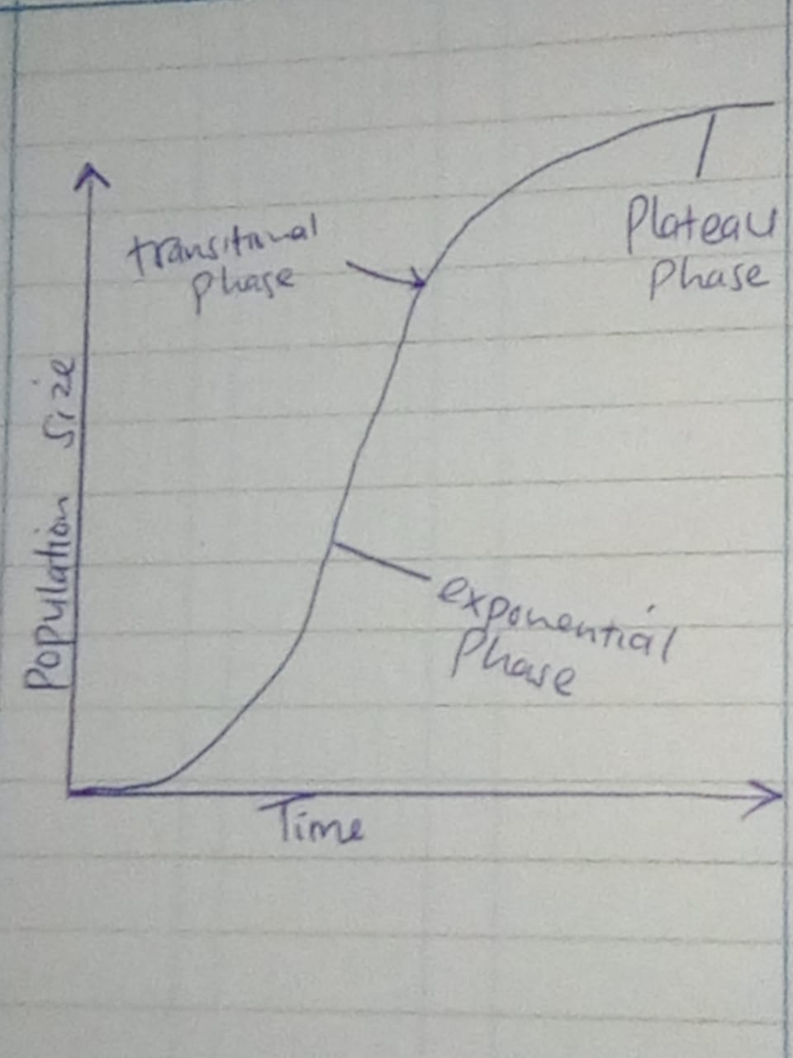
  - Carrying capacity is at the plateau phase. It means the number of living things that can survive in a particular ecosystem without degrading the environment.
  - If the natality in a population is higher than mortality, or immigration occurs, this would cause the [population to exceed the carrying capacity. Consequentially, members of the community would be forced to emigrate.
  - Abiotic factors – soil pH, famine. Biotic factors – death of animals, death of pants.
- In both, the two animals live together. In mutualistic relationship, both animals benefit from each other while in a commensalistic relationship, one animal benefits from the other.
- In both, one animal benefits while the other is harmed. In a parasitic relationship, the parasite lives in or on the host and keeps benefitting from it, while in predator-prey relationship, the predator hunts for the prey and feeds on it.
- Since the invasive species might take up all the benefits in the ecosystem, the relationship may not be pleasant and the native species may end up emigrating.
- Questions
  - Population
  - Ecosystem
  - Community
  - Hydrosphere
  - Biosphere
  - Individual

  - Trout
  - Bald Eagle Salamander Dragonfly Phytoplankton
  - Mayfly
  - Bald eagle
- Table:
 | Photosynthesis | Respiration
Starting Materials | Water, Carbon dioxide | Glucose, oxygen
What is produced? | Glucose, Oxygen | ATP, Carbon dioxide, water
What group(s) of organisms perform the process? | Plants | All living things
What is the purpose of the process? | To make their own foods | To produce energy.

  - Through burning of fossil fuels. Through extreme cutting down of trees.

    - Combustion
    - Diffusion
    - Volcanic eruption
    - Photosynthesis
    - Burial
    - Decay
    - Sedimentation
    - Erosion
    - Respiration

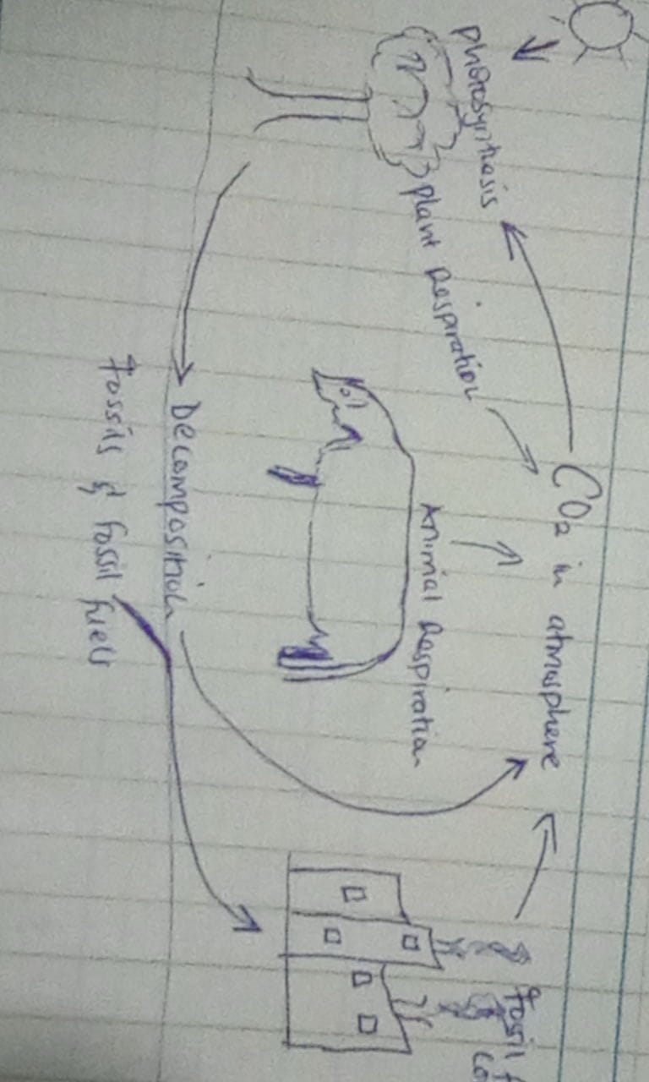

ASTRONOMY
- Astronomical unit refers to a distance of 150 million km, an estimated distance from earth to the sun. It is used when measuring distances in the solar system or between stars.
- A light year is an astronomical unit used to measure distance and defined as the distance that light can travel in one year. It is roughly 9.5 x 10¹² km. It is used to define distances in between stars and galaxies especially when written in popular publications.
- Planets
  - Mercury
    - 88 days a year
    - 0 moons
  - Venus
    - 0 moons
    - 462 ⁰C surface temperature
  - Earth
    - 24 hours a day
    - 365 days a year
  - Mars
    - 2 moons
    - 24 hours, 37 minutes a day.
  - Jupiter
    - The largest planet.
    - -108 ⁰C surface temperature.
  - Saturn
    - Less dense than water
    - Composed of hydrogen and helium.
  - Uranus
    - 27 moons
    - 17 hours 14 minutes per day.
  - Neptune
    - Size of 57.7 earths
    - Density of 1.63 g/cm³
- Mercury, Venus, Earth, Mars. They are smaller than the outer planets, they have rocky surfaces, and they contain an iron core.
- Jupiter, Saturn, Uranus, Neptune. They are bigger than the inner planets, they have rings around them, they are made of gases, thus they lack solid surfaces, and they have multiple moons.
- True or false
    - False
    - False
    - False
    - True
    - True
    - False
    - False
- The cosmic microwave background. Relative abundances of light elements.
- Table
 | Lifetime | When it runs out of fuel it becomes…
Low Mass Stars | High | White dwarfs
High Mass Stars | Low | Pulsars/black holes
- Blue, blue-white, yellow, orange, red.

